Resume of Hu Zejun

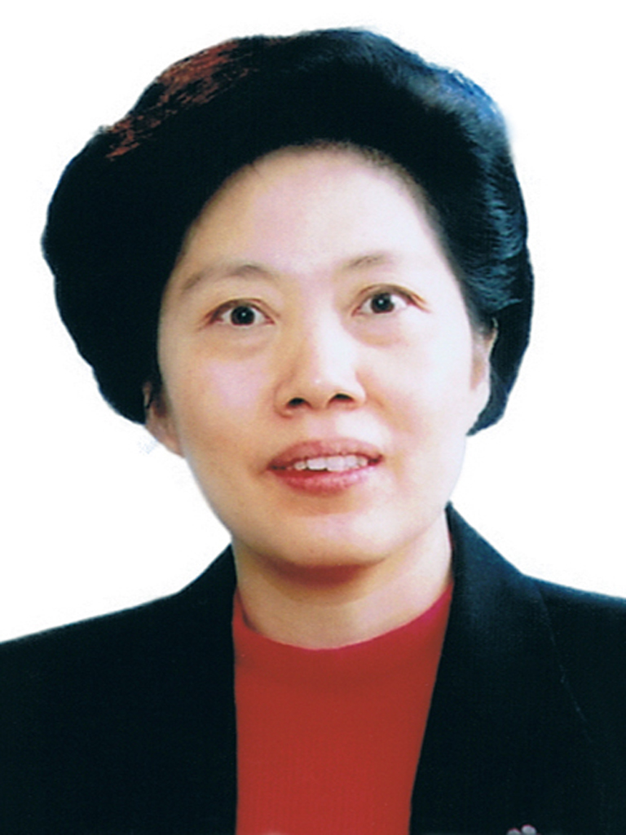

Ms.Hu Zejun, born March, 1955 in Chongqing China. Graduated from the Law School of the Southwest Institute of Political Science and Law. With a postgraduate education, LL.M, Associate Professor, First Grand Prosecutor.

1978—1982, student of the Southwest Institute of Political Science and Law, China
1982—1985, postgraduate student of the Law School of the Southwest Institute of Political Science and Law in China, obtaining LL.M
1985—1995, lecturer, Deputy Chief and Associate Professor in the Southwest Institute of Political Science and Law, China
1995—2001, Deputy Director General of the Political Department, Ministry of Justice of China
2001—2004, Vice Minister, Ministry of Justice of China
2004—2010, member of the Standing Committee and head of the Organization Department, CPC Guangdong Provincial Committee (June 2007, President of the Party School of the CPC Guangdong Provincial Committee and Director of the Guangdong Administration Institute; November 2007, President of the Guangdong Academy of Public Governance)
2010—April 2017, First Deputy Prosecutor General and member of the Prosecution Committee of the Supreme People’s Procuratorate of China (at the rank of Minister)
April 2017—present, Auditor General of the National Audit Office of China

